STEP 1: CREATE A HTML FILE

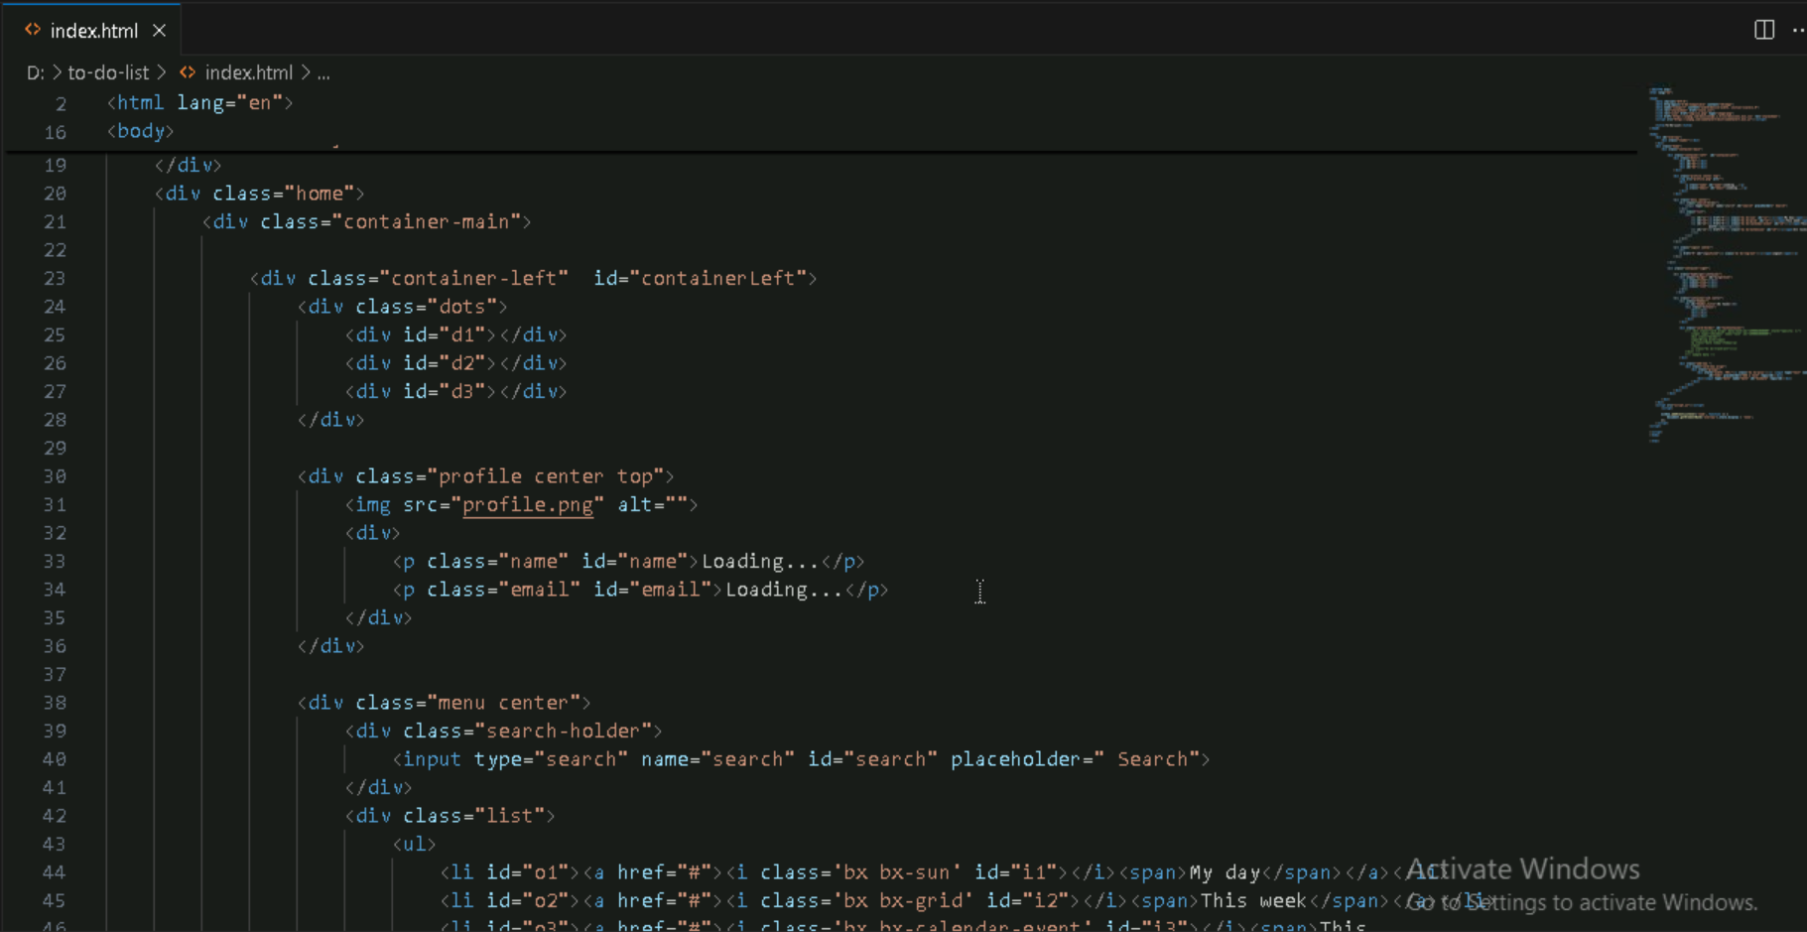

STEP 2: CREATE A CSS FILE

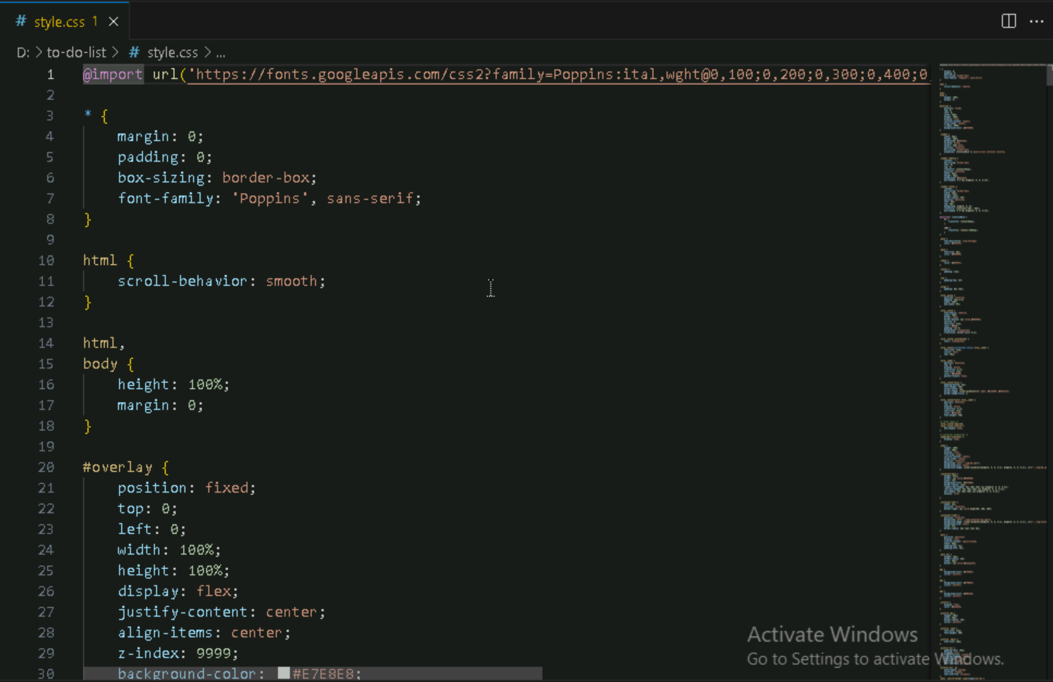

STEP 3: CREATE A JS FILE

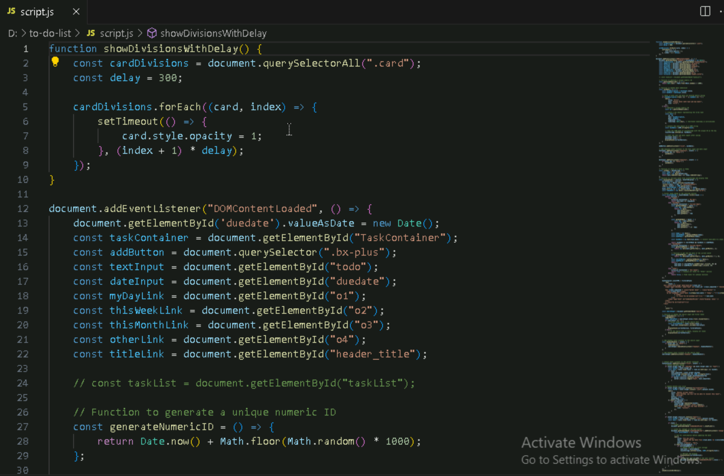

STEP 4: CREATE A REPOSITORY ON GITHUB

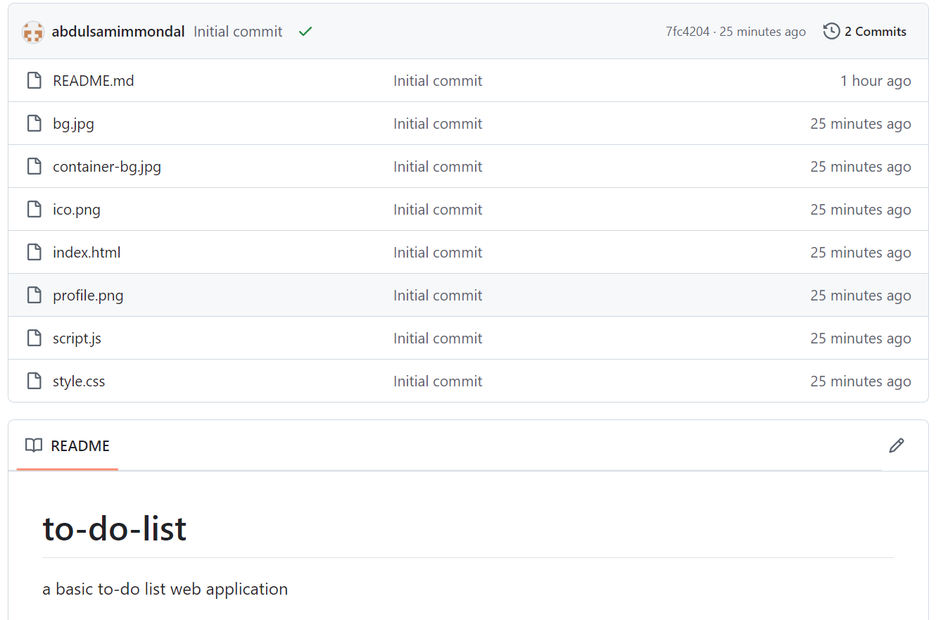

STEP 5: INITIALIZE LOCAL REPOSITORY

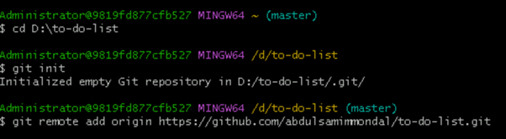

STEP 6: ADD THE FILES IN THE STAGING AREA THEN COMMIT THEM

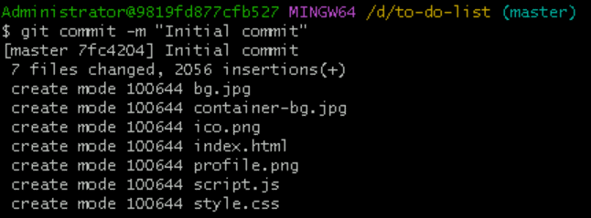

STEP 7: PUSH THE FILES INTO THE GITHUB REPOSITORY

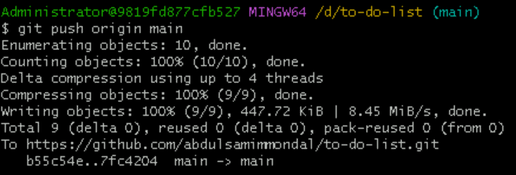

STEP 8: BUILD AND DEPLOY THE FILES IN GITHUB PAGES. CHOOSE SOURCE AS BRANCH AND SELECT MAIN.

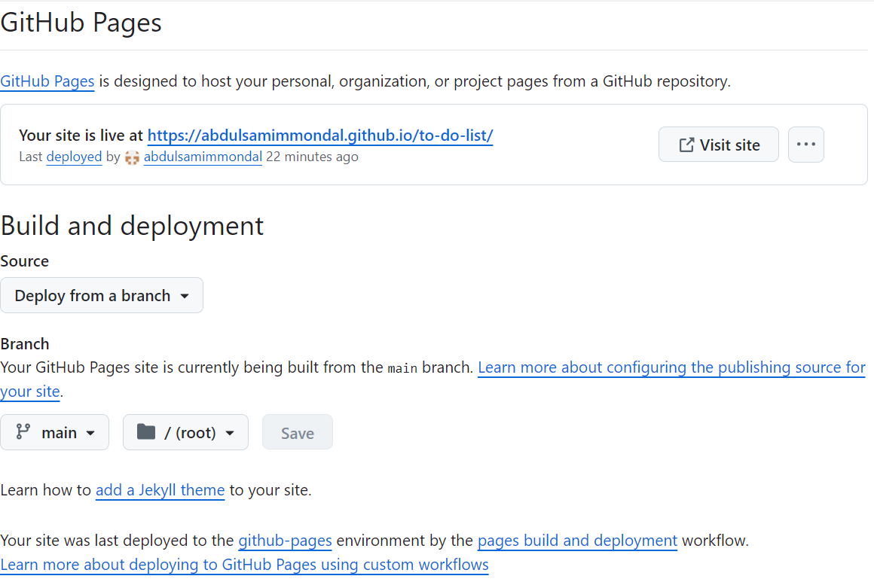

STEP 10: AFTER STEP 9 GITHUB WILL PROVIDE A LINK FOR THE WEBSITE. USE THE LINK TO ACCESS THE WEBSITE.

LINK: [**https://abdulsamimmondal.github.io/to-do-list/**](https://abdulsamimmondal.github.io/to-do-list/)

**SNAPSHOT OF THE WEBSITE:**

